PHASE 4: Project Planning Phase
Project Team Members
M.G Misriyathul Ibrahima
S.M.B.N Meera Jenira
V.Mohana
P.Mutharasi
S.A.K. Muthu Ameena

Project: Implement Client Script & UI Policy (Incident)
ServiceNow – Incident Management

Phase Objective
To organize the implementation into a sequence of configuration, testing, documentation, and demonstration activities.

Implementation Plan
- 1. Identify Incident data-quality problems.
- 2. Define functional and technical requirements.
- 3. Create the High Impact Control UI Policy.
- 4. Configure UI Policy Actions.
- 5. Create the onChange Client Script.
- 6. Create the onSubmit Client Script.
- 7. Create the onCellEdit Client Script.
- 8. Test mandatory enforcement and successful save.
- 9. Test reverse condition and list-edit restriction.
- 10. Prepare documentation and demonstration.

Planned Configuration Components
High Impact Control UI Policy; Urgency UI Policy Action; Auto set urgency for high impact – onChange; Prevent save if Assigned To missing – onSubmit; Prevent state change via list edit – onCellEdit.

Verification Plan
Testing was planned around both valid and invalid user actions so that the configuration could be checked under High Impact, non-High Impact, missing Assigned To, populated Assigned To, list editing, and normal form editing scenarios.

Project Evidence – Screenshots
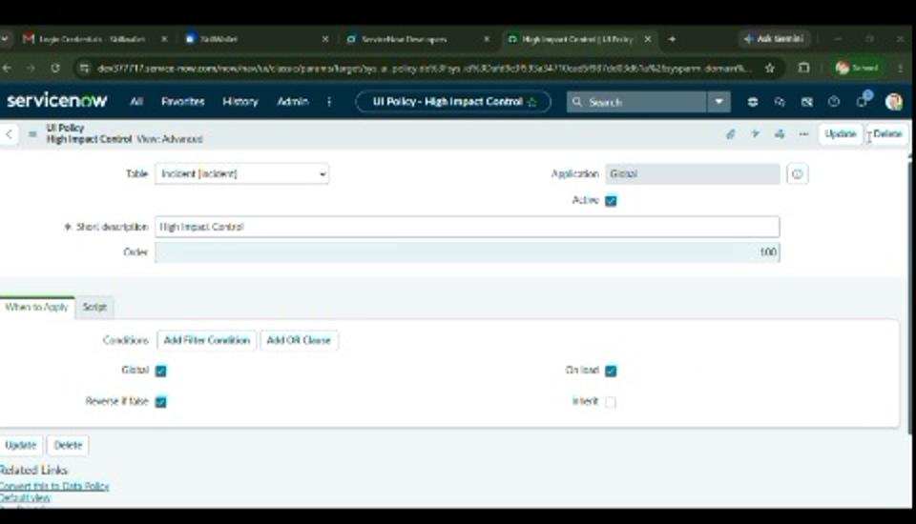
Figure 6. Saved High Impact Control UI Policy used as implementation evidence.

Phase Outcome
The implementation and verification activities were organized into a practical sequence from configuration through testing and demonstration.

